***Objective Questions:***

**1. In analyzing the hospital dataset with Power BI, ensure data cleaning to address inconsistencies and missing values before further analysis.**

To perform data cleaning, the Excel file and CSV file are imported into the Power Query editor.

"Sheet1" is renamed to "**Hospital Doctor Data**" and duplicate entries are removed from the dataset. Additionally, there are no empty values in this data.

“Hospital ER” is renamed to “**Hospital Patient Data**” and duplicate entries are removed from the dataset.

72% of the satisfaction score are null values, so it is taken as blank to analyze the data.

**Split Column by delimiter-** In the date column, where both date and time values were present, the column was split using a delimiter, and the column name was changed to “time”.

**2. *Assess the Average Waiting Time:* Analyze the patient wait times to identify the average duration a patient spends before receiving care.**

A measure **“Average Waiting time=AVERAGE ('Hospital Patient Data'[patient_waittime])”** is created to determine the average waiting time in Power Bi desktop. Average waiting time is **35.26**.

**3. *Visits by Department Referral:*** **Calculate the total number of visits to each department based on referrals to understand which departments are most frequently visited.**

**General practice** department has the highest number of visits (**7240**) followed by **orthopedics** (**995**) and others. Number of visit = COUNT ('Hospital Patient Data'[patient_id]) to find the total number of visits. A column chart is used to display the total number of visits to each department.

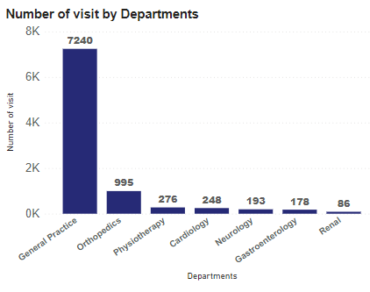

**4. *Patient Visits by Age Group:* Segregate patient visits according to different age groups to see which demographics utilize healthcare services the most.**

In the power query editor, the patient age column was segregated using a **conditional column**. In Power BI Desktop, a tree map chart is created to display Patient Visits by Age Group. The table includes an age group column representing the count values. There is no significant difference in the number of visits among the age groups; however, **30-40** has utilized the healthcare service the most.

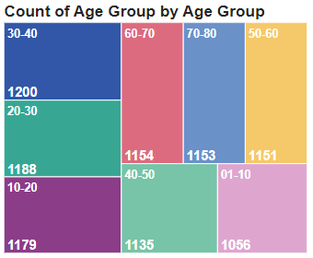

**5*. Average Satisfaction by Demographics:* Determine the relationship between patient satisfaction scores, their age groups, and racial backgrounds to pinpoint areas for improvement in patient experience.**

70 % of the satisfaction score is left blank so to determine the area for improvement the area with the highest number of **“0 satisfaction scores”** is considered. The below table displays the racial backgrounds and age groups with “0 satisfaction scores”

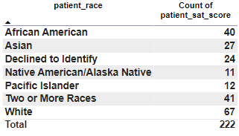  
From the table, it is evident that the patients of **white** racial background have given more “0 satisfaction scores” when compared to others. The age group table shows no major differences concerning satisfaction scores. So patients with white racial backgrounds need more attention.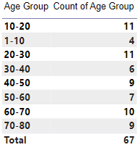

**6. The hospital's managing director seeks to evaluate the revenue of each department to understand how much revenue is generated by each.**

In Power BI Desktop, the column chart provides each department and their total bills. Here, we can identify the revenue generated by each department. Looking at the chart, it's clear that **Orthopedics** has the highest revenue, which is $172,939,773, while **Renal** has the lowest revenue at $4,756,367.

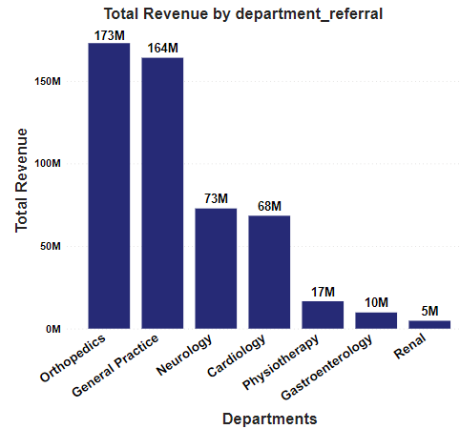

**7.** **Is there any relation between the number of visits and the Gender of the patients?**

The number of visits for the **female and male** patients is 4487 and 4705 respectively. So, there is no actual relation between the number of visits and the Gender of the patients.

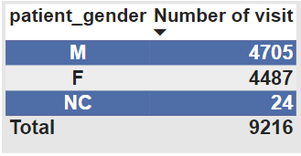

**8. Which department is charging the highest appointment fees in general?**

A donut chart is used to display the variations in the appointment fees across different departments. It is clear that the **Neurology** department stands out with the highest appointment fee, set at **$1500**.

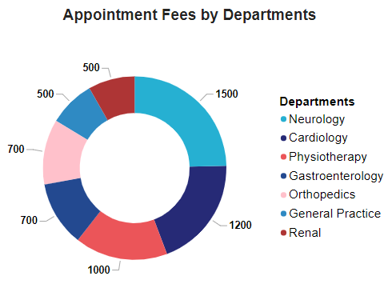

***Subjective Questions:***

**1. What is the relation between patient wait time and satisfaction scores?**

There is no relation between how long a patient waits and their satisfaction scores. **Satisfaction scores** generally fall between 1.2 and 1.8, while **wait times** typically range from 34 to 36. Extended wait times are not linked to lower satisfaction levels across different departments.

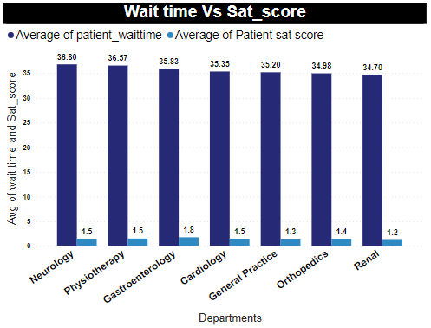

**2.** **How do patient demographics affect the frequency of visits to different departments?**

| **Department** | **Maximum and Minimum no. of Visits of Patients across** | | |
| --- | --- | --- | --- |
| **Race** | **Age group** | **Gender** |
| General practice | White - **2015** | 20-30 -**957** | Male -**3685** |
| Native American/Alaska Native - **390** | 01-10 -**826** | Female-**3535** |
| Orthopedics | White -**305** | 10-20 -**138** | Male -**539** |
| Pacific islander -**51** | 70-80 -**106** | Female- **453** |
| Physiotherapy | White-**81** | 10-20 -**47** | Female -**139** |
| Native American/Alaska Native-**6** | 50-60 -**24** | Male -**137** |
| Cardiology | White-**62** | 50-60 -**37** | Male -**130** |
| Pacific islander -**17** | 40-50 -**25** | Female -**118** |
| Neurology | White-**45** | 10-20 -**29** | Female -**100** |
| Pacific islander -**14** | 70-80 -**21** | Male-**93** |
| Gastroenterology | White-**39** | 70-80 -**28** | Female -**100** |
| Native American/Alaska Native-**10** | 20-30 -**15** | Male -**77** |
| Renal | White-**24** | 30-40 **23** | Male -**44** |
| Pacific islander -**4** | 40-50 **05** | Female-**42** |

In the above chart maximum(...) and minimum(...) number of visits for each department based on Race, Age group, and gender is displayed. From the table it is evident that White people visit each department the most and Native American/Alaska Native, Pacific islander are the least. From the analysis, General practice department leads with the number of visits in each age group. So the above table shows the maximum and minimum number of visits in each department. The age group 30-40 visits the hospital most. For gender, there is no major difference.

**3. Is there a noticeable trend in the volume of patient visits throughout the year?**

|  |  |
| --- | --- |

The data suggests a pattern in patient visits throughout the year. During June, July, August, the hospital experiences the highest demand for healthcare services, with 2648 visits. In the months of December, January, February, there are 1870 visits, followed by 2358 in March, April, May, and 2340 in September, October, and November. Overall, it appears that people tend to visit the hospital more frequently during the ***middle of the year***.

|  |  |
| --- | --- |

**4. Which age groups report the highest and lowest satisfaction scores?**

In the **50-60** age groups, people had the best experience with a satisfaction score of 5.33. On the other hand, in the **70-80** age groups, the satisfaction score is 4.45, which is not as bad, but it indicates that this age group experienced a less positive experience compared to all other age groups.

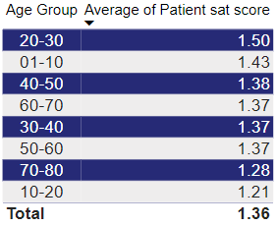

**5. The hospital management intends to offer discounts to patients.**

Offering discounts during specific months namely, **January**, **February, and March** in 2019 and **November, December in** 2020, could potentially boost the number of patient visits. During these months, there tends to be a lower number of patient visits, and providing discounts might encourage more people to seek healthcare services during these periods.

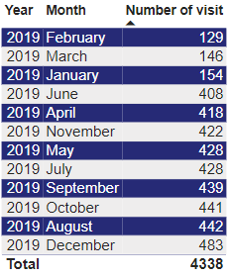 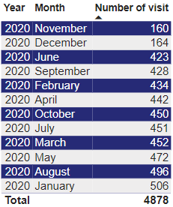

**6. The hospital has a budget to hire 2-3 new doctors.**

In the **General Practice department**, a total of **7240** patient visit, but currently, there are only 3 doctors. Therefore, hiring an additional 3 doctors for the General Practice department would be beneficial.

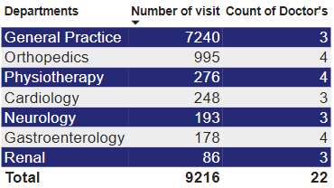

**7. Is the hospital profitable?**

The total profit for the year 2019 was $240,408,248, and for the year 2020, it increased to $268,900,869, showing an increase of $28,492,621. This indicates that the hospital is making a profit.

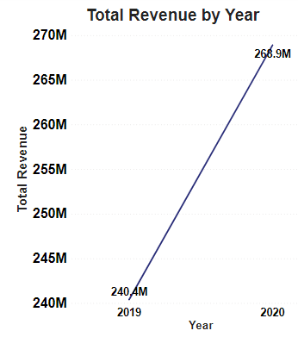

**8. Any Department for which the waiting time is oddly large?**

The average waiting time across all departments is consistently around **35 to 37** minutes, and there are **no unusual differences** observed among the departments.

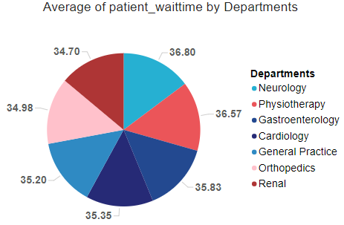

**9. Come up with strategies to provide discounts to the patients.**

We can offer discounts in the **General Practice** department for individuals aged 20-30. Additionally, we can provide discounts to white patients who have visited the hospital repeatedly, totaling 2571 visits. Furthermore, considering the expected lower number of patients in December, January, February, and March, discounts can be offered during these months.